**MGT559F**

**Leading in a Circular Economy**

**Group-based Assignment**

**January 2023 Semester**

|  |
| --- |
| Name |
| JANNIK ALEXANDER JOLITZ |
| SRUTHI MADHUSUDANAN |
| NOOR ASYIKIN BINTE MUSTAFFA |
| MOHAMED SHAMMIR S/O THIRUNAUC KARASU |
| SHI HAOYU |

Submission Date: 13 April 2023

Table of Contents

Question 1(a) 3

Question 1(b) 4

Pillar I: Circular Eco-design 4

**Using New Eco-friendly Materials to Express the Design** 4

Pillar II: Resource Management and Circular Procurement 6

**Circular Inputs** 6

**Renewable Energy (H&M, 2021)** 7

Pillar III: The Extension of the Life Cycle 8

Pillar VII: New Life of Products and Materials 9

**Garment-to-garment Recycling System ‘Looop’ (2020)** 9

**Smart Recycling Bins (2020)** 10

Spider Web Diagram 11

Question 1(c) 11

References 14

**H&M and Circular Economy**

# **Question 1(a)**

H&M is a globally recognized fashion retailer headquartered in Sweden. The company's dedication to sustainability is evidenced by the implementation of various schemes, including the "Conscious Collection" and "Close the Looop" initiatives. H&M's product range includes clothing items for men, women, and children, as well as accessories and home decor.

They have launched several initiatives in line with the upcoming ISO 59.010 standard for the circular economy to promote sustainability and minimise waste. The company has set a target to become completely circular and climate positive by 2030. This goal includes the introduction of a circular textile recycling system, where old clothes are collected and sorted for reuse, repair, or recycling. H&M's emphasis on sustainable materials and circular systems promotes responsible resource usage, reducing waste and encouraging circularity in its business operations.

H&M's circular textile recycling system involves cooperation with suppliers and recycling partners, fostering industrial and territorial symbiosis. By collaborating with other businesses and stakeholders, H&M can establish a more circular system that benefits everyone involved. The company's pilot clothing rental services promote a functional approach to fashion, allowing customers to rent clothes for specific events instead of purchasing new ones. This initiative extends the life cycle of H&M's products and reduces waste, taking a significant step towards a more sustainable future.

Despite the company's efforts and accomplishments to become more circular, there have also been numerous accusations against H&M of greenwashing to improve its image. In 2019, the Norwegian Consumer Authority accused H&M of misleading consumers with claims about its Conscious Collection (Kaner, 2021). There have been repeated cases of H&M marketing their products as sustainable, but this was subsequently proven to be false. The company has since stepped up its commitment to resource conservation and more "real" sustainability in 2019.

# **Question 1(b)**

## **Pillar I: Circular Eco-design**

### **Using New Eco-friendly Materials to Express the Design**

H&M is committed to using eco-friendly materials in its designs (FashionNetwork, 2018). This includes using Tencel fibre, natural coloured cotton, eco-wool, recycled glass, corn fibre and other plant fibres in garment production. In addition, H&M uses dandelion as a filling material instead of down. For several years, H&M has been the largest user of organic cotton globally and has been using certified organic cotton since 2004. Since 2007, all H&M stores sell garments made from 100% organic cotton, which are categorised under the “Conscious” Collection. This sustainable fashion production approach is an example for the fashion industry, promoting environmentally friendly materials and reflecting H&M's commitment to creating sustainable fashion.

In Paris, H&M launched the Conscious Exclusive Collection in 2016 (Rachel, 2021), which focuses on producing high-end clothing using eco-friendly fabrics and craftsmanship. The garments in this collection were made using ecological silk, recycled denim, linen, and organic cotton that had been grown with a higher environmental factor.

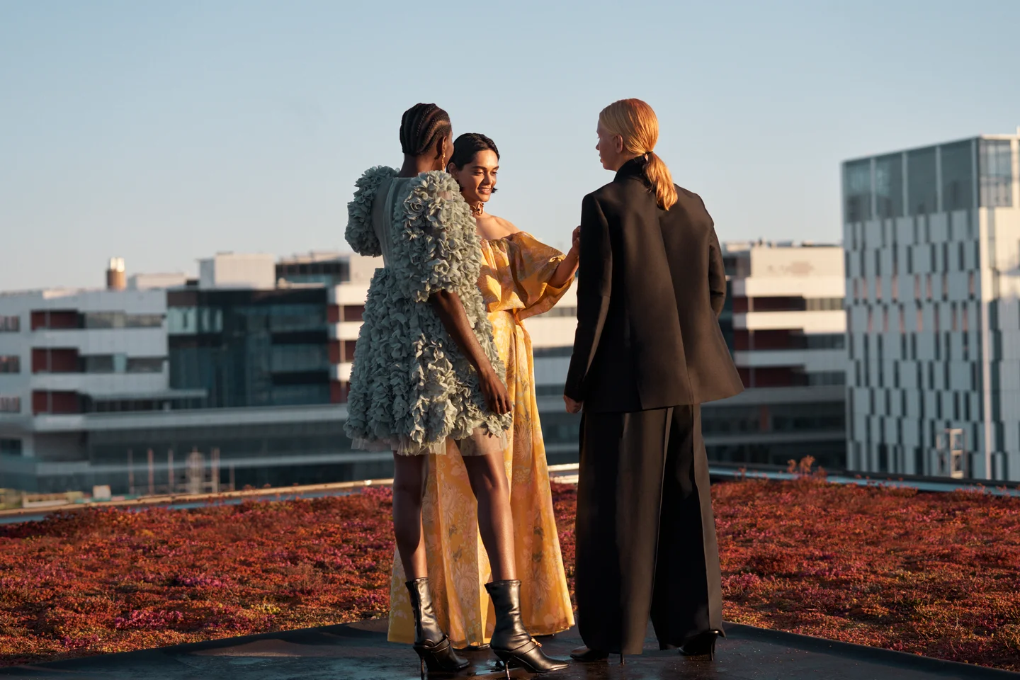

Figure 1: H&M's Conscious Exclusive Collection (Source: www2.hm.com)

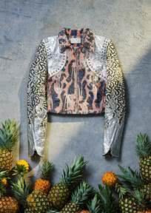

Figure 2: Jacket, made of pineapple leaf fibre leather.

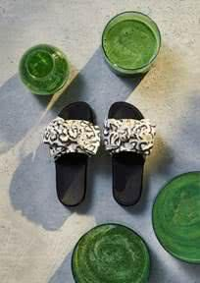

Figure 3: Beach slipper with an insole made of seaweed flexible sponge foam.

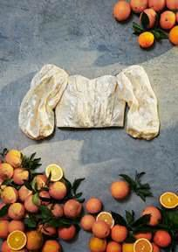

Figure 4: Strapless blouse, made of citrus peel fibres.

Pineapple Leaf Fibre Plant Leather is a natural leather alternative made from cellulose fibres extracted from pineapple leaves. Seaweed flexible sponge foam is derived from algae organisms that overgrow in freshwater and is a plant-based elastic foam made from algal biomass. Citrus peel fibres are derived from the by-products of citrus juice and are reprocessed to make a cellulosic fibre like real silk.

## **Pillar II: Resource Management and Circular Procurement**

### **Circular Inputs**

Sustainable bio-based recyclable materials are sourced by H&M. By 2030, H&M intends to use 100% recycled, closed loop, or other sustainably sourced materials. H&M has invested in developing and utilising a wide range of alternative recycled materials, resulting in energy and water savings as well as lower greenhouse gas emissions (Shen, 2014).

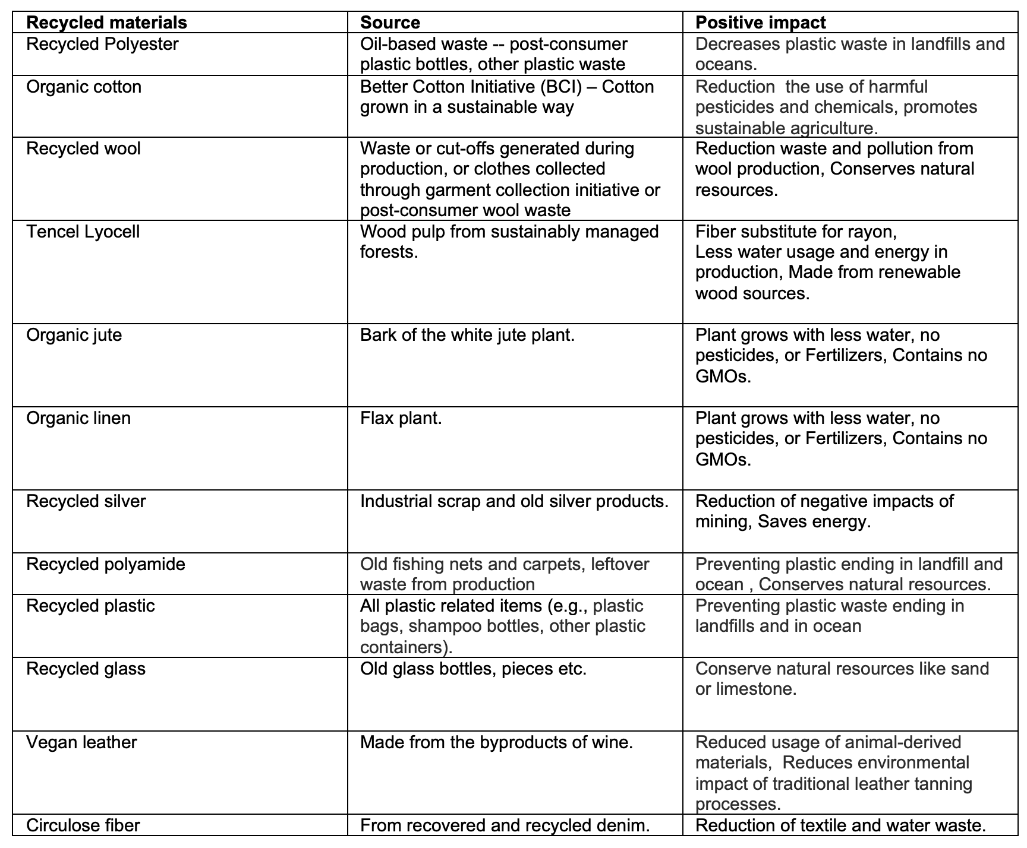

Figure 5: Sustainable bio-based recyclable materials

### **Renewable Energy (H&M, 2021)**

· H&M halted adding any new suppliers or supplier factories to its supply chain as of January 1, 2022, if such facilities have on-site coal boilers. This is part of a longer-term plan to phase out coal from their supply chain.

· Solar panels were placed at 5 of the distribution centres, with a total peak capacity of 1,375 MWh.

· In 2021, 95% of the electricity needed for operations was renewable and the brand aims for 100 percent renewable energy by 2030.

· There are now 34 markets where climate-smart delivery options are available. Last-mile delivery utilising electric cars have been implemented as a part of the solution because of the on-going convergence of online and offline sales.

Collaborated with suppliers to implement renewable electricity and heat projects:

· On-site renewable electricity sources have been deployed by 75% of H&M HOME providers.

· 18% of the world's COS clothing production, or around 60%, is manufactured in Turkey utilising renewable electricity.

· HSBC, WWF, and the World Resources Institute worked together on a project in Indonesia to solve obstacles in employing biomass boilers.

## **Pillar III: The Extension of the Life Cycle**

H&M has implemented various ways to extend the life cycle of its products. Firstly, H&M has incorporated the idea of rewarding its customers with “Thank You” vouchers when they donate old clothes to the staff at the counters under H&M’s garment collecting program. These clothes, from any brand, in any condition, will be accepted, and customers will receive a voucher of 15% off for their next purchase (for each donated bag). Collected clothes are sorted into three categories – re-wear, reuse and recycle (Farra, 2020).

Though recycling falls under the pillar of new life of products and materials, re-wear and reuse fall under the extension of life cycle. Under their re-wear category, clothes that are still in wearable condition are marketed and sold as second-hand clothing at a cheaper price. In 2020, H&M collected approximately 19 tons of garments of which 57% were under the re-wear category (H&M Group, 2021).

Under the reuse section of the garment collecting program, garments collected which are not suitable for re-wear are reused and repurposed to other products. In their re-manufacture process, they will re-engineer the products such as using portions of different old denims to create a new pair of denim jeans or creating cleaning cloths from old garments. Garment production waste such as trimmings are also incorporated for subsequent products to eliminate waste (H&M Group, n.d.).

H&M’s Jeans Redesign Project ensures that a minimum of 20% of any product should use recycled content and is made with a modern textile innovation containing viscose made with Circulose. It is a cellulosic made from textile waste and wood pulp which is made into viscose textile fibres. These products can be repaired and subsequently recycled to new fibres (H&M Group, 2021).

## **Pillar VII: New Life of Products and Materials**

### **Garment-to-garment Recycling System ‘Looop’ (2020)**

**Business Aim:** To restore value in a product that can still be reused, albeit in a new, re-invented format.

Opened in Stockholm on October 12, 2020, customers are now able to watch the container-sized machine recycle their old textiles into something new. The innovative technology behind Looop has been developed by HKRITA in collaboration with H&M Foundation.

The whole process, which uses no water or chemicals, takes between five (5) and eight (8) hours. Customers choose the garment type via an app and leave the old clothing with attendants. The process does not dye the fabric, but mixes existing coloured fabrics, hence, to an extent, the colours are customisable.

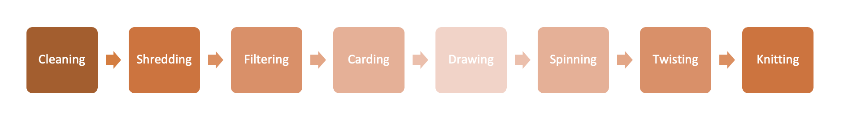Figure 6: Garment-to-Garment Recycling System ‘Looop’

Figure 7: Garment-to-garment Recycling System ‘Looop’

### **Smart Recycling Bins (2020)**

**Business Aim:** Shifting social and cultural mindsets towards public understanding regarding recycling and educating the masses on the long-term benefits of recycling as a whole.

This supercharges its Garment Collecting Programme with smart clothes recycling bins which not only accept donations, but also offer customers a new, (Wynne, 2022) engaging experience.

Shoppers place their bag into the bin allowing for their donations to be weighed, and a real time tally of the donation will be presented on-screen alongside a QR code which can then be scanned to receive a 15% discount for next purchase and contains information about its other sustainability initiatives.

Figure 8: Smart Recycling Bins

## **Spider Web Diagram**

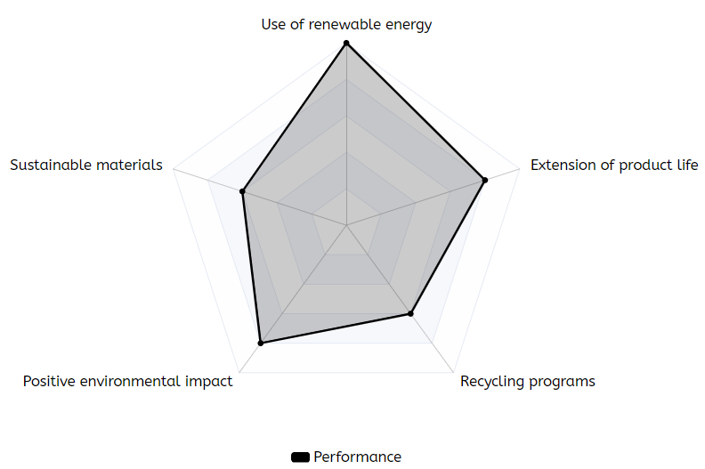

Figure 9: Spider web diagram

# **Question 1(c)**

The circular economy model that H&M can look to expand or re-look into would fall under the **Product as a Service**. They can offer subscription services to consumers as an extension or diversification of their current product offerings without having to veer from their main business model.

By starting a subscription-based membership for fashion-conscious people similar to Style Theory (<https://www.styletheory.co>), H&M can leverage on its consumers to move away from supporting fast fashion by providing personalised stylists to curate a miniature capsule collection of six clothing options that is personalised for individuals. The outfits will be used by each subscriber and subsequently swapped out for a new collection at the end of 30 days. Should the subscriber like a particular garment, they can then opt to extend its rental at a consigned price, for a limited time of one month. Curation of collections occur monthly, and subscribers can select their fashion requirements or trends that they would like the stylist to be mindful of in their selections via an online checklist through an app. Outdated collections can then be reinvented / remanufactured using the company’s Garment-to-garment Recycling System ‘Looop’ initiative. The main advantage of this service business model is that the number of replicated garments are reduced significantly, so as to increase its exclusivity and move consumers towards putting in more thought before purchasing their next fashion find. Reducing the number of replicated garments also allows for more timeless, premium and quality creations to be produced at a far slower rate - thus, the company can also shift its focus towards slow fashion (Marquis, 2021). Outfits that are typically used for certain milestones in a woman’s life, for example, maternity outfits and wedding gowns would also be parked under this subscription model.

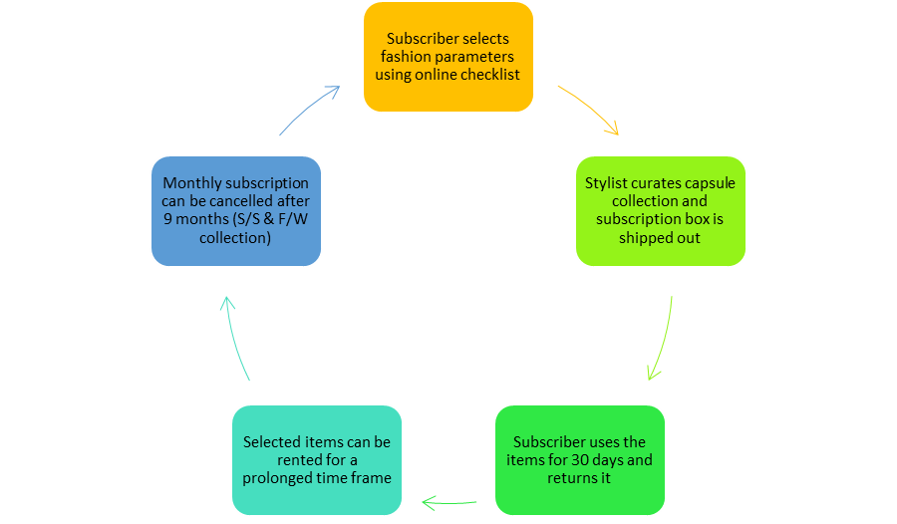

Figure 10: Subscription-based membership model

H&M is also a pioneer in rolling out collaborations with celebrities and fashion designers, with the latest being Mugler for its 2023 Spring collection (Cary, 2023). Hence, the introduction of the subscription line will allow mass market consumers to get up-close and personal with their favourite fashion designers and icons without breaking the bank, nor compromising on quality and style. By shifting consumers towards the subscription platform, the company can then make its foray into slow and sustainable fashion.

Another policy that should be high on H&M’s list considering its recent greenwashing scandal (Shendruk, 2022), would be to **implement transparent circular policies** that push for the certification of the company’s social and environmental performance. Where H&M had previously faced a class-action lawsuit over publishing wrong environmental scores and misleading plus false sustainability marketing claims, the company can now work towards being **OEKO-TEX(R) 100 Certified** (<https://www.oeko-tex.com>). By having the STANDARD 100 label on its textile garments, H&M can then justify that each component of its garment, from buttons, zippers and fabric dyes have been tested for harmful substances and safe for human use.

Given that OEKO-TEX operates globally, getting independently certified would add credibility to the company’s currently waning reputation and increases quality assurance across the board. H&M, which has been accused of riding on the coattails of its ‘Conscious Collection’ to advocate that its entire product catalogue is sourced via sustainable methods (Ponte, 2023), can now utilise the OEKO-TEX® STANDARD 100 certifications to ensure that its entire line is indeed transitioning towards actual sustainable fashion and not relying on half-truths. In doing so, the company can synchronously create shared value (CSV) by educating customers on the importance of having a STANDARD 100 label on all textile garments. By combining its monthly fashion subscription with the OEKO-TEX® STANDARD 100 certifications, this then promotes the ideology of buying once, but buying well - akin to what Patagonia has been doing (Ramaniah, 2019). It would also simultaneously place H&M at the forefront once again, but for all the right reasons - being ethically and environmentally conscious.

Word Count: 1933

# **References**

Huber, E. (2020, December 3) H&M’s New Sustainable Collection Includes Boots That Can Turn Into Mules. <https://www.refinery29.com/en-us/2020/11/10175416/hm-conscious-exclusive-sustainable-collection-fall-2020>

Cary, A. (2023, February 22). Mugler Is H&M’s Latest Designer Collaboration. Vogue.<https://www.vogue.com/article/hm-mugler-collaboration#:~:text=Sharpen%20your%20elbows%E2%80%93today%2C%20H%26M,in%20selected%20stores%20spring%202023>.

Farra, E. (2020, Nov 21). H&M Takes a step toward circularity with a collection of garments made from waste. Retrieved from VOGUE:<https://vogue.sg/hm-conscious-collection-recycled-waste-circularity/>

FashionNetwork. (2018, October 24) H&M leads the fashion industry when it comes to sustainable materials.<https://ww.fashionnetwork.com/news/H-m-leads-the-fashion-industry-when-it-comes-to-sustainable-materials,1027542.html>

H&M Group. (2021). Sustainability Performance Report 2020. Retrieved from<https://hmgroup.com/wp-content/uploads/2021/03/HM-Group-Sustainability-Performance-Report-2020.pdf>

H&M Group. (n.d.). Collect, recirculate and recycle. Retrieved from H&M Group:<https://hmgroup.com/sustainability/circularity-and-climate/recycling/>

H&M. (2021). HM-Group-Sustainability-Disclosure-2021. Retrieved from<https://hmgroup.com/wp-content/uploads/2022/03/HM-Group-Sustainability-Disclosure-2021.pdf>.

H&M. (2022). Retrieved from Materials:<https://hmgroup.com/sustainability/circularity-and-climate/materials/>

Kaner, G. (2021). Greenwashing: How Difficult It Is to Be Transparent to the Consumer—H&M Case Study. Green Marketing in Emerging Markets: Strategic and Operational Perspectives, 203-226. <https://link.springer.com/chapter/10.1007/978-3-030-74065-8_9>

Marquis, C. (2021, May 14). What Does Slow Fashion ‘Actually’ Mean? Forbes.<https://www.forbes.com/sites/christophermarquis/2021/05/14/what-does-slow-fashion-actually-mean/?sh=92090f873b4d>

Ponte, C. (2023, February 27). The H&M Greenwashing Scandal: Has Business Learned the Lesson? Impakter.<https://impakter.com/hm-greenwashing-scandal-has-business-learned-the-lesson/#:~:text=Last%20summer%2C%20Quartz%20carried%20out,Index%2C%20which%20is%20H%26M%20sustainability>

Rachel. (2021, February 11) ‘Sustainable style’: How conscious is H&M Conscious?<https://www.whatwonderwomenwear.com/how-conscious-is-it-to-buy-hm-conscious/>

Ramaniah, Z. (2019, December 12). H&M’s Greenwashing: Short-Sighted and Unethical. Brandingmag.<https://www.brandingmag.com/2019/12/12/hms-greenwashing-short-sighted-and-unethical/>

Shen, B. (2014). Sustainable Fashion Supply Chain: Lessons from H&M. <https://www.mdpi.com/2071-1050/6/9/6236>

Shendruk, A. (2022, September 4). USA: H&M faces 'greenwashing' class-action lawsuit over alleged misleading & false marketing of ‘sustainable’ clothing line. Business & Human Rights Resource Centre.<https://www.business-humanrights.org/en/latest-news/usa-hm-faces-greenwashing-class-action-lawsuit-over-alleged-misleading-false-marketing-of-sustainable-clothing-line/>

Wright, B. (2018, October 24) H&M named world’s biggest user of sustainable cotton<https://www.just-style.com/news/hm-named-worlds-biggest-user-of-sustainable-cotton/>